|  |  |  |
| --- | --- | --- |
| C:\Users\Dr Palanimuthu\Documents\University Logo Black(1).jpg | ***University of Agricultural Sciences, Bangalore***  **ICAR-Krishi Vigyan Kendra**  **Bengaluru Rural District**  **Krishi Mantana**  **Vol. 3 Quarterly Newsletter (April – June 2015) No. 2** | http://3.bp.blogspot.com/-Aui_5lNJsoQ/Tm7xKFOUqgI/AAAAAAAAAis/7pvXshp0Ruc/s1600/icar+logo.jpg |

**On Farm Testing (OFT) approved for 2015-16**

1. Assessment of multi cut Fodders for yield and quality
2. Assessment on management of late blight in Potato
3. Assessment on foliar spray of micro nutrients in Rose (var. Cherishma)
4. Assessment of Jackfruit residue as silage for Dairy animals
5. Solar drying – A hygienic technique for value addition in Jack

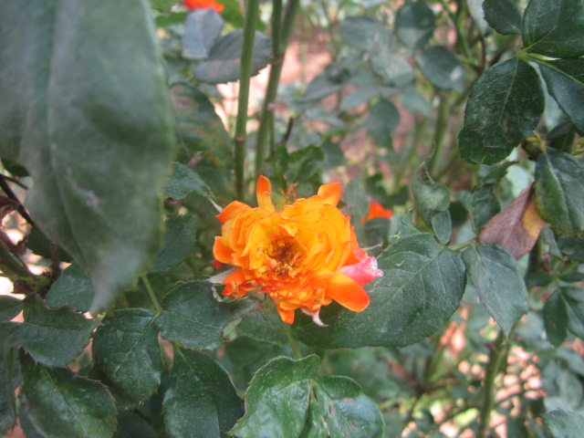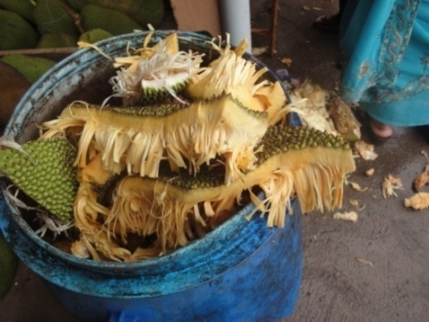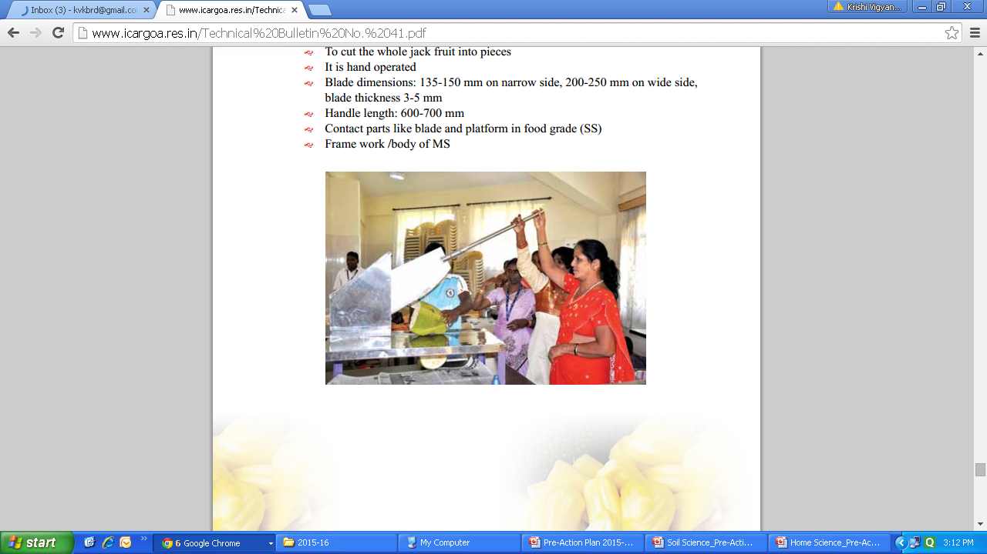

**Front Line Demonstrations (FLD) approved for 2015-16**

1. 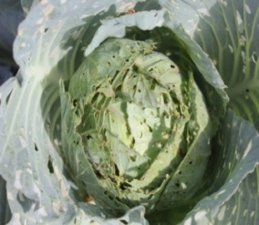Addressing drought and blast in Finger millet (NFSM)
2. Integrated crop management in Redgram (NFSM)
3. Photo insensitive Field bean variety HA-4 for enhanced returns (NFSM)
4. Promotion of fodder cafeteria for regular green fodder availability
5. 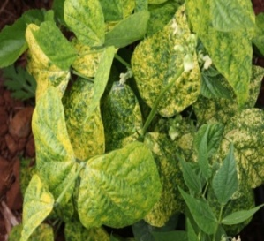Intercropping of Fodder Cowpea in grain Maize (NFSM)
6. Eco-friendly management of diamond back moth and black rot in Cabbage
7. Integrated management of late blight in Tomato
8. Management of nut splitting in Arecanut
9. 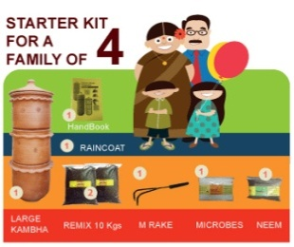Integrated crop management in Pole beans
10. Integrated crop management in Capsicum
11. Bio fertilizer and SOP for enhanced yield in Potato
12. Integrated nutritional interventions in Dairy animals
13. Management of mastitis at sub-clinical stage in Dairy animals
14. Integrated management of Endo & Ecto parasites in Dairy animals
15. Vegetable roof gardening and Eco friendly management of kitchen waste for health security

**Krishi Abhiyana**

The Agriculture Department of Bengaluru Rural district organized Krishi Abhiyana programmes in all the taluks during pre-kharif period in collaboration with ICAR-Krishi Vigyan Kendra, Bengaluru Rural District (ICAR-KVKBRD) and other development departments such as Horticulture, Sericulture, Animal Husbandry, Fisheries, Marketing and other agriculture input dealing private organizations.

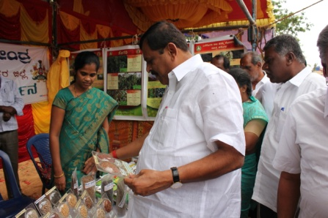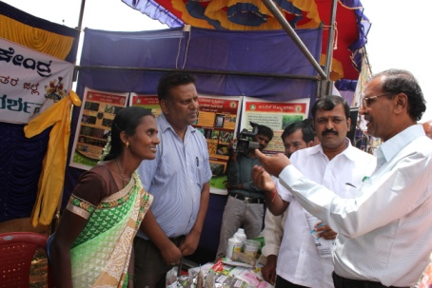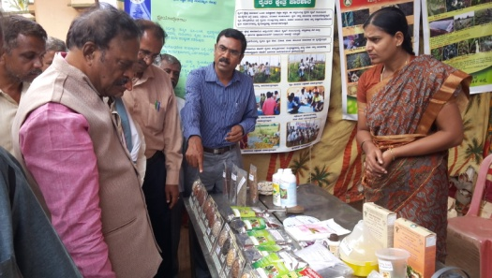

Sri Venkataramanaiah, MLA Sri Ashwathnarayana Sri J Narasimhaswamy

Doddaballapura constituency Ex TP member, Sasalu hobli EX-MLA, Doddaballapura taluk

The objective of the programme was to create awareness among the farming community about the farm activities to be undertaken in kharif season. The farmers were provided understanding about critical agricultural practices such as deep ploughing, green manure crops, compost application, latest high yielding varieties of the crops, seed selection, seed treatment, sowing methods, calculation of nutrient requirement for the crops, method of application, spacing, intercrops, etc. As a part of the Krishi Abhiyana programme agricultural exhibitions were arranged by ICAR-KVKBRD in all the hoblis of Doddaballapura taluk.

**On Campus Capacity Building Programmes**

**Friends of Coconut Tree (FOCT)**

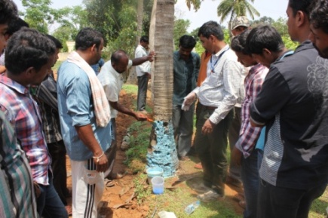Coconut is one of the important plantation crops in Bengaluru Rural district. The acreage under this crop is declining due to non-availability of labour to take care of trees and for harvesting the nuts. To address this problem, two vocational trainings were conducted for 60 farm youth of Bengaluru Rural district about coconut tree climbing using machine and integrated crop management practices to be adopted during coconut cultivation.

**Integrated Farming System (IFS)**

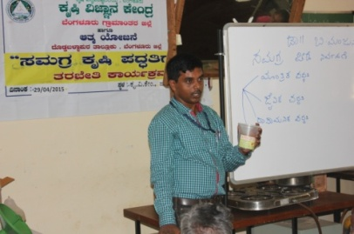Farmers of Tubagere hobli of Doddaballapura taluk participated in training programme about Principles and Practices of Integrated Farming System (IFS). This programme was organized in collaboration with Department of Agriculture under ATMA. Different topics such as IFS models suitable for dryland systems, Integrated nutrient and pest management practices, experiences of farmers practicing IFS, sustainability of IFS farms, etc. were discussed in length with the trainees.

**One Year Diploma in Agriculture under Distance Education**

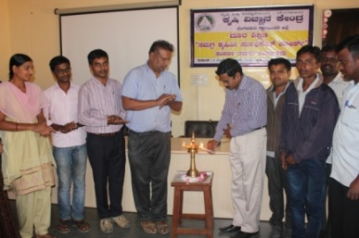Contact classes were conducted for the students who registered for One Year Diploma in Agriculture under Distance Education through University of Agricultural Sciences, Bengaluru for the year 2014-15. The major objective of this diploma course is to increase the capacity of the farmers to adopt scientific practices in agricultural production and marketing.

**Bi-monthly Workshop**

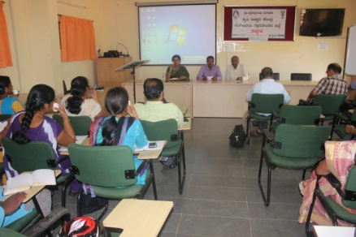The Directorate of Extension, University of Agricultural Sciences, Bengaluru organized **Bimonthly Workshop** for development departments in collaboration with ICAR-KVKBRD. The participants presented the field conditions observed during April and May months, 2015 and highlighted about the expectations of the farmers. Scientists from UAS, Bengaluru and ICAR-KVKBRD discussed about the field operations to be carried out in the next two months, contingency crop planning, etc.

**Off Campus Capacity Building Programmes**

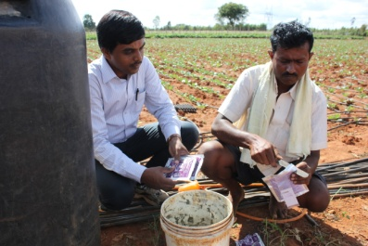 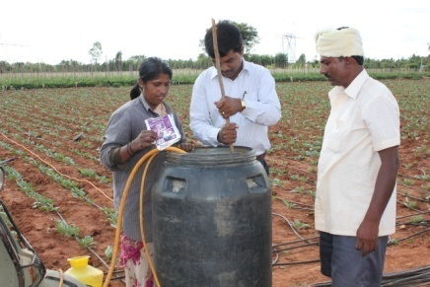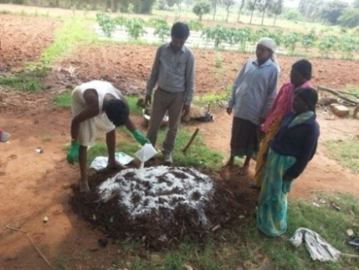

Preparation of spray solution Enrichment of FYM with bioagents

**Farmers Field School**

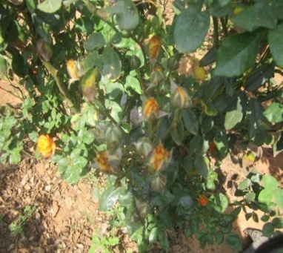Rose is grown in about 1,000 ha in Bengaluru Rural district. The major problem faced by rose cultivators is high cost of cultivation due to indiscriminate use of fertilizers and plant protection chemicals to control pests such as thrips, aphids and diseases such as black spot, downy mildew and powdery mildew. To create awareness among farmers about INM and IPM in rose, Farmers Field School about ICM in Rose was initiated in Alappanahalli village, Kasaba hobli, Hosakote taluk.

**Important Visitors to ICAR-KVKBRD**

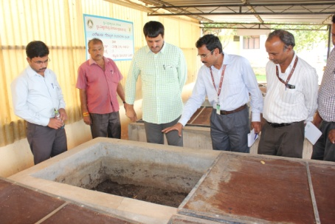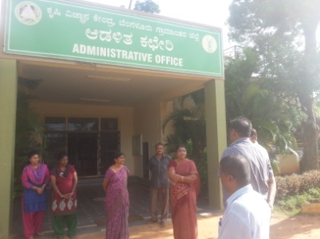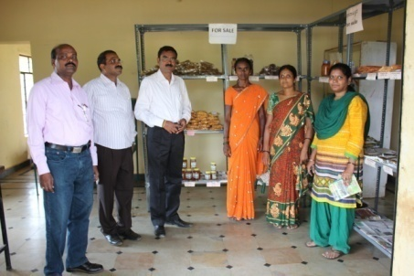

Sri C.P.Yogeshwar, MLA Smt.Shailaja, CEO PC, ICAR-KVK Karnal and

Channapatna Constituency Bengaluru Rural District PC, ICAR-KVK Bellary

**Services available at KVK**

* Analysis of soil and water samples and advisory services for soil health and water management
* Analysis of infected plant samples and advisory services about IPM practices
* Production and sale of quality planting material and advisory services
* Production and sale of Vegetable Special
* Millets Processing Centre
* KVK Marketing Complex
* Biofuel Production and Sale

**Services and Sale of Technological Inputs**

* Analysis of Fifty one soil and forty three water samples of farmers and advisory services
* Sale of 3 kg Vegetable Special for use in various vegetables
* Sale of 26 quality horticultural planting materials
* About 39 q of seeds of Finger millet (MR-6 and ML365) and 15 q of seeds of Redgram (BRG-2 and BRG-5) were produced in KVK Farm under Seed Production programme

**Plant Health Clinic**

* Examination of 55 infested plant samples and advisory services to the farmers
* Diagnostic visits in Cheelenahalli, Nagashettihalli, Karepura, Puttayana Agrahara Channarayapatna, Yeliyur, Madhure, Sulibele, Alappanahalli, Devanahalli, Madhure villages

|  |  |  |  |
| --- | --- | --- | --- |
| **Chief Editor**  Dr. K.N. Srinivasappa  Programme Coordinator  **Editor**  Dr M Padmavathi  SMS (Agril. Extension) | **Associate Editors**  Dr S M Savita  SMS (Home Science)  Smt B G Vasanthi  SMS (Soil Science)  Sri V Madhu Kumar  SMS (Agronomy) | | Dr Anand B Manegar  SMS (Animal Science)  Dr B Manjunath  SMS (Plant Protection)  Smt B V Manjula  Training Assistant |
| **Contact For Further Information:**  Programme Coordinator, Krishi Vigyan Kendra, Hadonahalli, Doddaballapura Taluk, Bengaluru Rural District, Karnataka – 561205  **Phone:** 080-2765208 **Email:** [kvkbrd@gmail.com](mailto:kvkbrd@gmail.com)  **Website:** [www.kvkbrd.org](http://www.kvkbrd.org) | | To  -------------------------------------------------------  ------------------------------------------------------- | |