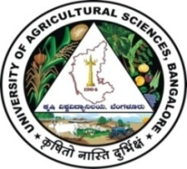 | University of Agricultural Sciences, Bangalore  ICAR-Krishi Vigyan Kendra, Bengaluru Rural District  Krishi Mantana  Vol. 6 Quarterly Newsletter (Oct - Dec, 2018) No. 4 | 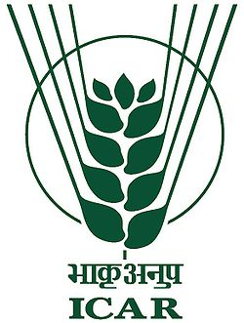
Celebration of Important days

Activities on Swachatha Hi Sewa Hai Programs (15th Sept, 2018 to 3rd Oct, 2018)
 | - Carried out several swachhta activities as a part of Swachhta hi sewa to create awareness among the public about the importance of hygiene for good health and their role in maintenance of clean surroundings.  - 15 activities viz., Oath taking, Cleaning of office premises, Cleaning of farm equipments, Celebration of Sewa Diwas, Displaying the banner, Pledge by the trainees of DAESI programme and staff, Cleaning of KVK demo units like office premises, Cleaning of approach road to KVK, Government Higher Primary School Premises and Essay writing competition for school children, Creation of awareness among school children, Village panchayath members, Ghati Temple Management Committee members, road side traders and villagers about importance of cleanliness, sanitation, hygiene, safe disposal of non biodegradable waste, maintenance of village drains and hazards of parthenium plants and open defecation, awareness on proper disposal of pooja ingredients (garlands, coconut husks, shells, tulasi leaves) to maintain cleanliness in temple premises, Campaign on composting of biodegradable waste, Pasting of slogans related to cleanliness in the village and Gandhi Jayanthi celebration. |  | 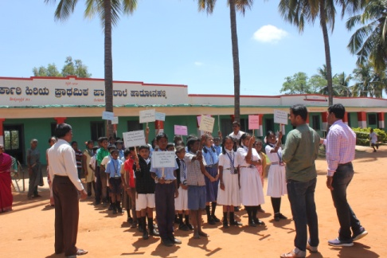  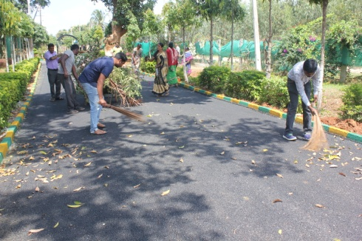
Celebration of Mahila Kisan Diwas
“Mahila Kisan Diwas” was organized in the campus on 15-10-18. Dr. Venkate Gowda, Scientist (Agronomy), explained about the importance of celebration of Mahila kisan diwas and role of farm women in Agriculture activities. Dr. Y. D. Chitra, Scientist (Agril. Extn.) mentioned the role of women from sowing to harvesting, Dairying, Poultry, Sheep rearing and Apiary. On the occasion, six district level award winning farm women were felicitated and also they shared their experiences in farming. The debate on farm women v/s farmer’s contribution in doubling the farm income and essay competition on Role of farm women in Agriculture were conducted. Exhibition was arranged on minor millets and value added products. Dr. M.J. Chandre Gowda, Director, ATARI, Bengaluru explained the Integrated farming system and their use, processing and value addition. He expressed his happiness for great success of women enterprises and he also distributed the prizes and certificates to winners.

- Celebration of World Food Day
“World Food Day” was organized in the campus on 16-10-18 for DAESI students and Self help group members. Dr. Veeranagappa, P., Scientist (Soil Science), briefed the importance of food to combat malnutrition in rural areas and present Agriculture scenario and the future expected status and soil health.
Dr. Venkate Gowda, J., Scientist (Agronomy) explained this year theme “Our Actions Our Future – A Zero hunger world by 2030 is possible”. He discussed on the role of family members in agriculture to feed the world population. Dr. B. Manjunath, Scientist (Plant Protection) briefly explained about effect of indiscriminate use of pesticides and fertilizers on ill effect of health and stressed for safe and judicious use of fertilizers. Sri Obaleshappa, Coordinator, DAESI programme expressed that, hunger is a major problem in world and a Zero hunger world by 2030 is possible with integrity and hard work. 45 DAESI students and members of self help groups were participated in the programme.
- Celebration Vigilance week
As per the instructions from ATARI, ICAR-Krishi Vigyan Kendra implemented the vigilance awareness week during 29th October to 3rd November 2018. All employees of KVK have taken an oath on anti-corruption on 30th October. 500 pamphlets were distributed to public, DAESI students and school children and displayed banner of vigilance awareness week in both kannada and English. In this occasion Senior Scientist and Head sensitized the employees on attendance, punctuality, accountability, accounts, work commitment, administration etc.
In Govt. Higher primary school, Shiravara, KVK Scientists sensitized the school children and teachers on vigilance awareness by Pledge and conducted essay competition on Eradicate corruption – Build a New India on 30.10.2018 and the winners were awarded.

World food day | Mahila kisan diwas | Vigilance week

Celebration of ‘Women in Agriculture Day’
‘Women in Agriculture Day’ was celebrated on 4th December, 2018 on the campus. On this occasion Dr. B. Manjunath, Senior Scientist and Head (I/c) conveyed the message about importance of women in Agriculture and also explained about the new farm equipments designed by the scientists which will reduce the drudgery of farm women in agriculture. Sri Lakshme Gowda, Progressive farmer explained about the importance of income generating activities and role of farm women in every activities of agriculture. KVK staff and 50 farm women were participated in the programme.

Celebration of ‘World soil day’
World Soil health day was organized in collaboration with Department of Agriculture, Doddaballapura on 5th December, 2018 at Rameshwara village, Doddaballapur Taluk, Bengaluru Rural District. Programme was inaugurated by Sri Gangaraju, President, Grama Panchayath, Hadripura, Sri Narayanaswamy, Member (GP) and Sri Narayanaswamy, ADA, Doddaballapura.
On this occasion, 58 soil health cards were distributed and there were 142 people participated and five exhibition stalls were arranged.

Celebration of Farmers Day:
Farmer’s day was celebrated at Devanahalli, Bengaluru Rural District in collaboration with agriculture, horticulture, sericulture, veterinary department and Krishika samaja on 23.12.2018. The programme was inaugurated by Sri. Nisarga Narayana Swamy, Member of Legislative Assembly. Zilla Panchayath and Taluk Panchayath members were also participated. In this programme, Interaction with farmers related to agriculture and related enterprises were organized. Six exhibition stalls were also arranged by various line departments. Progressive farmers were felicitated in the function.
Women in Agriculture day | World soil day | Farmers day
- Training programme on Importance of Integrated pest management and safe use of pesticides
The KVK was organized two days orientation training programme on “Importance of integrated pest management and safe use of pesticides” from 30.10.2018 to 31.10.2018 for DAESI students sponsored by Central Integrated Pest Management Centre, Bengaluru, Directorate of Plant Protection, quarantine and storage. The programme was inaugurated by Dr. Elangovan, Deputy Director CIPMC, Bengaluru. In this training programme, the different topics on Integrated pest management, safe and judicious use of pesticides, Integrated disease and pest management in field and horticulture crops, mass multiplication of bio control agents, Integrated weed management etc. were covered by KVK scientists and CIPMC officers. 40 DAESI students were benefited during the programme.

Field days
Addressing Drought and Blast vulnerability using finger millet variety ML-365

Field day pertaining to Front Line Demonstration entitled ‘Addressing drought and blast vulnerability using finger millet var. ML 365’ was conducted on 30th November 2018 at Huskuru village, Doddabelavangala hobli, Doddaballapura taluk. 40 farmers and farm women from Huskuru and surrounding villages were participated in the programme. Dr. Venkate Gowda, J., Scientist (Agronomy) briefed the importance of ML-365 variety related to drought and blast resistance and suggested the farmers to go for ML-365 variety instead of GPU-28 as a medium duration variety. Dr. B. Manjunath, Scientist (Plant protection) briefed about the scientific management of pest and diseases in Finger millet. Farmers expressed their happiness for using ML-365 variety due to better yield even in drought situation occurred during this year.

Field day on FLD - Integrated crop management in maize
Field day on ‘Integrated crop management in maize’ was organized in Huskuru village, Doddabelavangala hobli, Doddaballapura taluk on 30th November 2018. Dr. B. Manjunath, Scientist (Plant protection) briefed about the scientific management of pest and diseases in maize, especially on control of Fall army worm. He suggested to spray hemamectin benzoate @ 0.4 gm/ltr of water during evening hours to control fall army worm. Dr. Venkate Gowda, J., Scientist (Agronomy) briefed the importance of herbicides and nutrient management. Dr. Veeranagappa, P., Scientist (Soil Science) suggested the farmers to go for soil test based nutrient management to curb imbalanced use of fertilizers. 60 farmers and farm women from Huskuru and surrounding villages were participated and benefitted from this programme.
On campus training programme on IPM | Field day on finger millet | Field day on maize

Best Farmer awards from Bangalore Rural district in Krishimela-2018
The University of Agricultural Sciences, Bangalore organized Krishi Mela 2018 from 15th –18th November, 2018 at GKVK Campus, Bengaluru. On this occasion 10 farmers were selected from Bengaluru Rural District and awarded as Best Farmer and Farmwomen.
S No | Name | Award
1 | Sri. Sridhar, M.R., Machonayakanahalli village, Nelamangala taluk | District level Best Farmer
2 | Smt. Manjula, P., Huskuru village, Doddaballapur taluk | District level Best Farmwoman
3 | Sri Venkatesha Murthy, M., Thuruvanahalli village, Doddaballapur Taluk | Taluk level Best Farmer
4 | Sri. Radhakrishna, S., Banahalli village, Hoskote taluk | Taluk level Best Farmer
5 | Sri Kiran, Y.R., Yaliyuru village, Devanahalli taluk | Taluk level Best Farmer
6 | Sri Thejesh, Kempalinganahalli village, Nelamangala taluk | Taluk level Best Farmer
7 | Smt N.A. Chethana, Huskuru, village, Doddaballapur taluk | Taluk level Best Farmwoman
8 | Smt. Manikyamma, P., Alappanahalli village, Hoskote taluk | Taluk level Best Farmwoman
9 | Smt Rajeshwari, Sunnaghatta village, Devanahalli taluk | Taluk level Best Farmwoman
10 | Smt Manjamma, Elachagere village, Nelamangala taluk | Taluk level Best Farmwoman

Services available at KVK
- Analysis of soil and water samples and advisory services
- Analysis of infected plant samples and advisory services about IPM practices
- Production and sale of quality planting material and advisory services
- Production and sale of Vegetable Special
- Millets Processing Centre and KVK Marketing Complex
- Production and Sale of Pongamia oil, Pongamia cake and biofuel
Services and Sale of Technological Inputs
- Analysed 180 soil and 170 water samples of farmers and advisory services
- Sold 9 kg Vegetable Special as foliar spray in vegetables
- Sold 57 quality horticultural planting materials
Plant Health Clinic
- Examined 17 infested plant samples and provided advisory services to the farmers

Chief Editor  Dr. A. P. Mallikarjuna Gowda,  Senior Scientist & Head  Editors and Associate Editors  Dr. B. Manjunath, Scientist (Plant Protection) | Dr. J. Venkate Gowda, Scientist (Agronomy)  Dr. P. Veeranagapa, Scientist (Soil Science)  Dr. Y. D. Chithra, Scientist (Agril. Extension) |  | Sri N. Jagadish  Farm Manager  Smt. B. V. Manjula  Programme Assistant (Lab)
Contact For Further Information:  Senior Scientist & Head, ICAR- Krishi Vigyan Kendra, Hadonahalli, Doddaballapura Taluk, Bengaluru Rural District, Karnataka – 561205 Phone: 94498 66928  Email: kvkbrd@gmail.com, Website: www.kvkbrd.org |  | To  --------------------------------------------------------  --------------------------------------------------------

