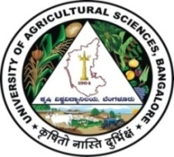 | University of Agricultural Sciences, Bangalore  ICAR-Krishi Vigyan Kendra  Bengaluru Rural District  Krishi Mantana  Vol. 6 Quarterly Newsletter (July - September, 2018) No. 3 | 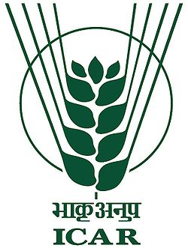
Webcasting of Prime ministers interaction with SHG members

Hon’ble Prime Minster interacted with SHG members from selected states of India on 12th July 2018 from 9.30 AM to 11.00 AM through webcasting. For this purpose, we have arranged web casting facility to facilitate live webcast to the farmers and SHG members of Bengaluru Rural District. In this programme, SHG members from Maharastra, Jammu and Kashmir, Gujarat, Madhya Pradesh, Rajasthan and Telangana were interacted and shared their experiences on benefits from value addition and marketing with Hon’ble Prime Minister. Prime Minister stressed the SHG members and Rural youth to utilize the traininigs and skill development programmes available in Gramina Rojagar yojane. | 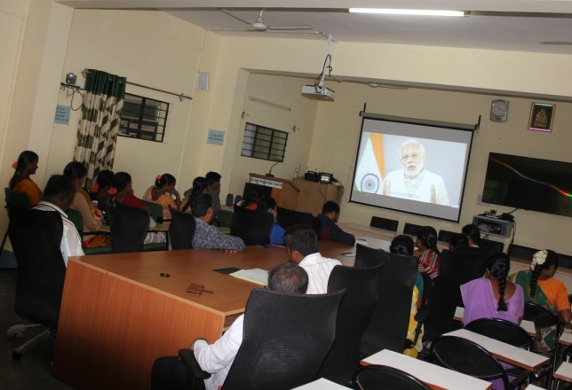
Further Dr. Venkate Gowda, J., Scientist (Agronomy) translated the Prime Ministers interactive programme to kannada and advised SHG members to become economically strong by utilizing the skill development trainings. In this programme staff of KVK, SHG members from Tubagere hobli were participated and appreciated the Prime Ministers concern on farm women and the chance to obtain knowledge on different activities carried out by SHG members in different states of India.

Geo Tagging of Integrated Farming System Demonstration General and Model Stake holders under RKVY Project
Integrated Farming System Demonstration Project funded by GOI under Rashtriya Krishi Vikas Yojana was taken up in 17 villages covering 2304 families by ICAR-Krishi Vigyan Kendra, Hadonahalli, Doddaballapur Taluk, Bengaluru Rural District during 2012-13 to 2015-16. Dhana Dhanya Lakshmi Agro Resource Centre was established under RKVY project during 31st August 2014. Dr. Chandrashekar Vastar, Chief Scientific Officer, Directorate of Research, UAS, Bengaluru, Dr. M.T. Sanjay, Associate Professor, AICRP(IFS) and Dr.Manjunath, B. Scientist (Plant Protection), ICAR-KVK, Bengaluru Rural District took up geo | 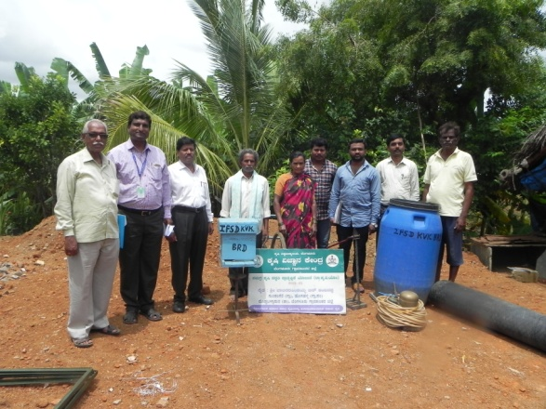
tagging of equipments purchased out of IFSD project and distributed to general stakeholders and model stake holders as per instructions from Govt. of India. Geo tagging task was undertaken in Hosahalli and Gundumagere village, Doddaballapur taluk.
Celebration of World Biofuel day
Celebrated world Biofuel day on 10th August 2018 at ICAR-Krishi Vigyan Kendra, Hadonahalli, Doddaballapura taluk. Dr. A.P. Mallikarjuna Gowda, Senior Scientist and Head, briefed the gathering about the different biofuel species, its uses, oil content (present) in different species and its availability and conversion of oil into biodiesel and use of biodiesel. Dr. B. Manjunath, Scientist (Plant protection), KVK, Bengaluru Rural District gave training to the farmers regarding uses and | 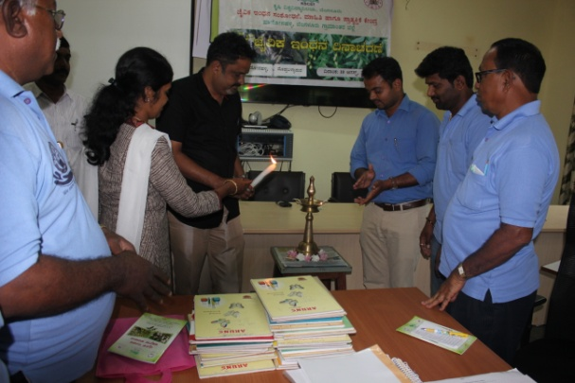
importance of neem oil, neem seed kernel, neem soap, pongamia soap, pongamia cake and neem cake etc., Dr. J. Venkate Gowda, Scientist (Agronomy) addressed the students regarding importance of Biofuels in future days.
Parthenium Awaress week
Parthenium is one of the weed which is causing more damage for cultivation of crops and also mankind. To create awareness about this weed, Parthenium Awareness Week was celebrated on 21.08.2018 at ICAR-Krishi Vigyan Kendra, Hadonahalli, Doddaballapura taluk. Dr. A. P. Mallikarjuna Gowda, Senior Scientist and Head, briefed the gathering about significance of celebration and the harmful effects caused by parthenium. Dr. J. Venkate Gowda, Scientist (Agronomy) briefed about various cultural methods of eradication, various management techniques such as methods of composting etc. | 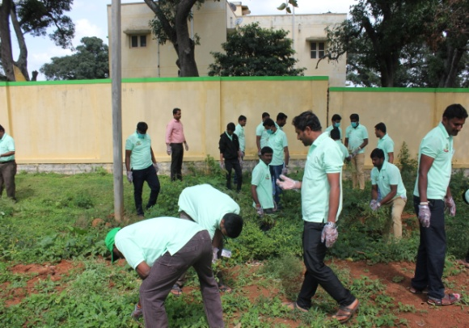
Dr. Manjunath. B explained about biological control methods for eradication of weed. 35 DAESI students and KVK staff wore hand gloves and uprooted parthenium weeds.

Method demonstration on nipping in Redgram
Method demonstration on nipping in redgram was carried out in the field of Mr. Nagaraj, farmer, S.S. Ghati village, Doddaballapur taluk under National Fodd Security Mission (Red gram CFLD programme) on 23.08.2018. Dr. J. Venkate Gowda, Scientist (Agronomy) explained about the nipping technique in redgram and its advantages. 15 farmers were participated and benefitted from the programme. | 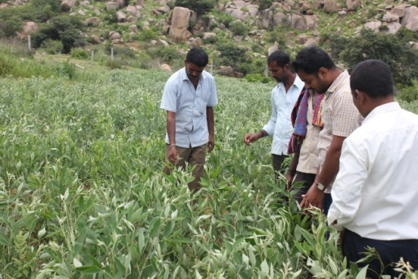

Rejuvenation of farm pond
The existing farm pond was rejuvenated by de-silting the accumulated silt over a period of time by using JCB for 140 hours. Further, the uneven shaped farm pond was formed into a straight line and one side of the pond was stone pitched. Three silt traps were constructed looking into the gradient and water flow during rainy season. | 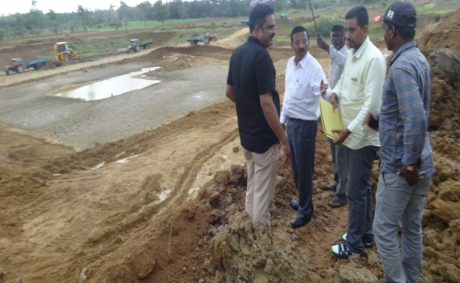

Valedictory and certificate distribution programme for DAESI students
The valedictory and certificate distribution programme for first batch of DAESI students was organized on 03.09.2018 at KVK. The Programme was chaired by Dr M.S. Nataraj, Vice Chancellor and Director of Extension, University of Agricultural Sciences, Bengaluru, Dr Pennobilaswamy, Coordinator, DAESI programme, Dr. K. Narayana Gowda, ADE, Dr. G.S. Nagaraja, Professor, DE office, University of Agricultural Sciences, Bengaluru, Dr Anuroopa, Deputy Director of Agriculture, Chikkaballapura, Sri Gopala Gowda, DTO, ATMA project, Dr A.P. Mallikarjuna Gowda, Senior Scientist & Head and all the staff of ICAR KVK, Bengaluru Rural were attended the programme. | 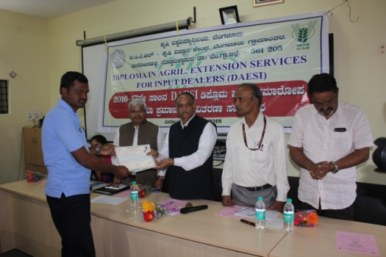

Dr. M.S. Nataraj, Vice Chancellor congratulated all DAESI students for successful completion and highlighted the role of extension services of input dealers in the future with regard to farming community. He also expressed to establish agriculture information centers at village level.
Dr. Pennobilaswamy explained the efforts took by the organizers in conducting the programme and the responsibility took by all the members to made it a grand success. Dr. Anuroopa mentioned the importance of diploma for input dealers and how it helps them to maintain integrity in their business services.
Cele bration of National nutrition week
The Awareness programme on National Nutrition Week - 2018 was celebrated on 06.09.2018 for SHG members at ICAR-Krishi Vigyan Kendra, Hadonahalli. Smt. Manjula B.V., Programme Assistant (Lab) delivered a lecture on “Importance of Nutrition and minor millets” and stressed the theme of the year “Go Further with Food”. The method demonstration on preparation of value added products from minor millets was carried out to 30 SHG members. The competition on preparation of nutritious foods from millets was conducted for SHG members and the winners were awarded by the staff of KVK. | 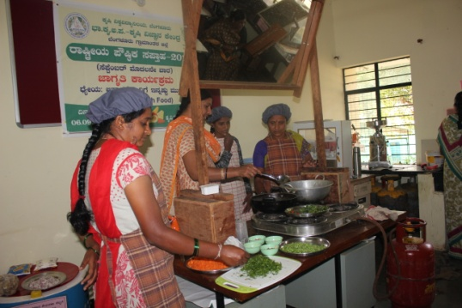

Review of KVK by Sri. D. V. Sadananda Gowda, Union Minister for Statistics and Programme Implementation, Govt. of India
The Honorable Union Minister Sri. D. V. Sadananda Gowda visited ICAR-Krishi Vigyan Kendra, Hadonahalli, Bengaluru Rural District on 11.09.2018. Dr. M. J. Chandre Gowda, Director, ATARI, Zone XI welcomed the Union Minister and gathering. Dr. A.P. Mallikarjuna Gowda, Senior Scientist and Head presented the KVK activities and Dr. K. Narayana Gowda, Former Vice-Chancellor briefed the achievements of KVK, concept of Integrated Farming System, Value addition and also about the commodity based associations.

Further, the Honorable Union Minister Sri. D. V. Sadananda Gowda addressed the gathering with respect to how to double the farmer’s income by 2022. He reviewed and appreciated the technologies and activities conducted by the ICAR-Krishi Vigyan Kendra, Bengaluru Rural. He also explained the importance of minor millets, dairy farming, sericulture and bee keeping. He suggested the KVK scientists to conduct monthly interactive sessions with the farmers and review the progress once in three months. He also insisted the KVK scientists to adopt latest technologies in order to achieve more crop per drop of water by following the Israel technology. Then he interacted with the farmers and discussed the problems faced by them in Agriculture and allied fields.  Sri Hanumantharayappa, President, Central Silk Board, Dr. Y. A. Narayanaswamy, MLC, Bengaluru, Sri H. Appayyanna, Zilla Panchayath Member and Director BAMUL and Dr. K. Narayana Gowda ADE and Dr. G.S. Nagaraja, Professor, Directorate of Extension UAS, Bengaluru were participated in the programme. | 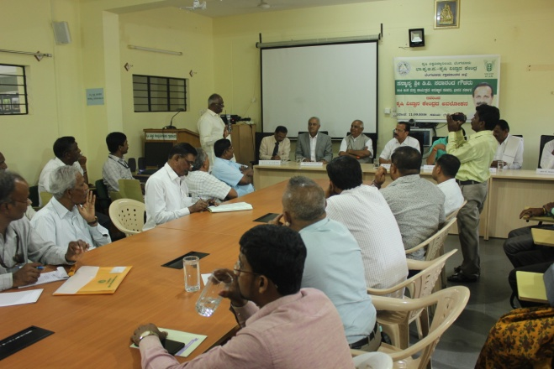  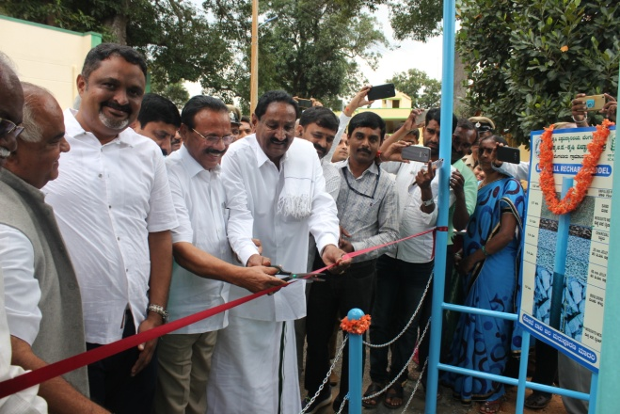
After the interactive session, Sri D. V. Sadananda Gowda inaugurated the Borewell recharge model established at KVK and visited all the demo units of KVK. He also planted coconut seedling as a remembrance of his visit to KVK. The Hon’ble Minister assured the farmers in safeguarding their interest by solving their problems with suitable solutions. Finally, he insisted all the Scientists of KVK to work hard in achieving the target of Doubling the farmer’s income by 2022.

Off-campus training programmes
Title of the programme | No. of participants
Biological and chemical methods for management of DBM in cabbage | 22
Management of stem borer in maize | 26
Management of Fall Army worm in maize through Integrated approach | 28
Enrichment of FYM with Paecilomyces lilacinus for nematode management in capsicum | 12
Integrated nutrient management in mulberry | 15

Services available at KVK
- Analysis of soil and water samples and advisory services
- Analysis of infected plant samples and advisory services about IPM practices
- Production and sale of quality planting material and advisory services
- Production and sale of Vegetable Special
- Millets Processing Centre and KVK Marketing Complex
- Production and Sale of Pongamia oil, Pongamia cake and biofuel
Services and Sale of Technological Inputs
- Analysed 137 soil and 137 water samples of farmers and advisory services
- Sold 121 kg Vegetable Special as foliar spray in vegetables
- Sold 283 quality horticultural planting materials
Plant Health Clinic
- Examined 87 infested plant samples and provided advisory services to the farmers
- Diagnostic visits were made in Obalapura, Lakshmidevipura, Gantiganahalli, S.S. Ghati, Laghumenahalli, Ballagere, Bachahalli, Bannimangala, Kuntanahalli, Rameshwara, Neralaghatta, Ballagere, Thippur, Huskuru, Tubagere
Chief Editor  Dr A P Mallikarjuna Gowda  Senior Scientist & Head  Editor  Dr B Manjunath  Scientist (Plant Protection) | Associate Editors  Dr J Venkate Gowda  Scientist (Agronomy)  Dr P Veeranagapa  Scientist (Soil Science) |  | Sri N. Jagadish  Farm Manager  Smt B V Manjula  Training Assistant
Contact For Further Information:  Senior Scientist & Head, ICAR- Krishi Vigyan Kendra, Hadonahalli, Doddaballapura Taluk, Bengaluru Rural District, Karnataka – 561205 Phone: 94498 66928 Email: kvkbrd@gmail.com ,  Website: www.kvkbrd.org |  | To  ---------------------------------------------------------  -----------------------------------------------------------

