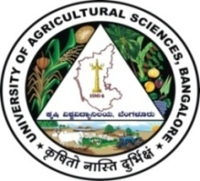 | University of Agricultural Sciences, Bengaluru  ICAR-Krishi Vigyan Kendra, Bengaluru Rural District  Krishi Mantana  Vol. 7 Quarterly Newsletter (April - June, 2019) No. 2 | 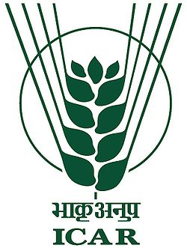

Celebratation of World Earth day

World earth day was celebrated on 22nd April 2019 at KVK in collaboration with District Legal Services Authority, Taluk Legal Service Committee, Advocate Association, Doddaballapur. The programme was chaired by Shri. M. B kulakarni, District Magistrator, JMFC Doddaballapura and inaugurated by watering the plant. On this occasion, Dr. A.P Mallikarjuna Gowda, Senior Scientist & Head, briefed on endangered and Extinct species of plants & animals and their preservation by conserving the environment. 50 members were participated in this programme.

Celebration of World Environment day

World environment day was organized on 5th June 2019 in collaboration with District Legal Services Authority, Taluk Legal Service Committee, Advocate Association, Doddaballapur and Department and Social Forestry, Doddaballapur at KVK, Campus.

Dr. A. P. Mallikarjuna Gowda, Senior Scientist and Head, KVK in his introductory remarks briefed about importance of World Environment day by highlighting the theme of the year as ‘Beat air pollution’. He explained the causes for air pollution and ill effects of the same on environment and requested everyone to join the hands in planting more forest species to protect the environment.

Smt. Mamatha Shivapuji, Additional Civil Judge & JMFC, Doddaballapur inaugurated the programme by planting and explained the responsibility of individual in protecting the environment. In this occasion, different forest species were planted in the premises of KVK.

Sri R. Byre Gowda, President, Advocate Association, Doddaballapura, Staff of KVK, Dept. of Social forestry, District legal service authority and DAESI students were presented in the programme.

Celebration of World Yoga day

As per the instructions of ICAR, World yoga day was organized on 21st June 2019 at KVK campus. Smt. Meenakshi, Assistant, KVK has briefed the importance of yoga for good health. All the Staff of Krishi Vigyan Kendra were actively participated in yoga excercises.
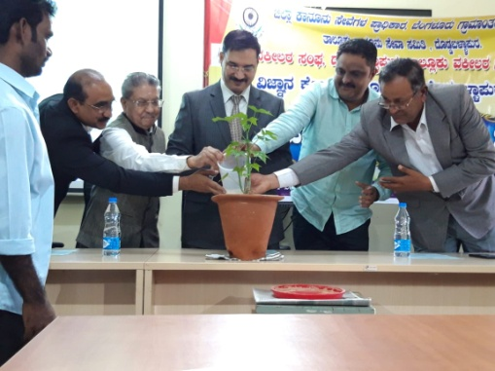 | 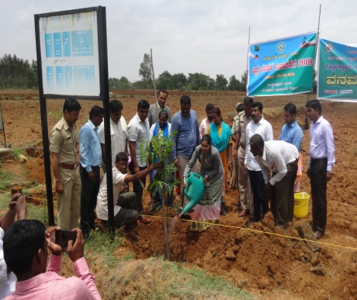 | 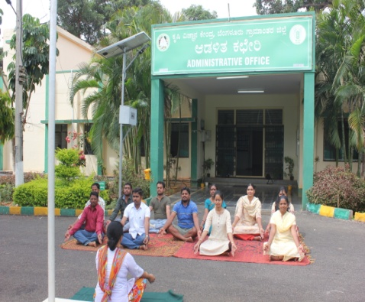
World earth day | World environment day | World yoga day

PRA for Village Adoption programme

Participatory Rural Appraisal was undertaken at Thuruvanahalli village, Doddaballapura Taluk on 26.06.2019. Dr. A. P. Mallikarjuna Gowda, Senior Scientist and Head briefed the farmers about the activities of village adoption programme and informed the farmers for active participation in the programme. He also emphasized on various capacity building programmes for Rural youth. Bench mark survey was carried out to ascertain the cultivation aspects and Socio-economic status of the farmers. About 65 farmers were participated in the programme.

PRA for FPO, Anekal

Participatory Rural Appraisal was carried out at Anekal Horticulture farmer producer company Limited on 19.06.2019. Dr. Manjunath, B., Scientist (Plant Protection) briefed about FPO activities being undertaken by the KVK for the financial year 2019-20. Dr. Chithra, Y. D. discussed about the various capacity building programmes for FPO farmers. Sensitization and selection of farmers were carried out to undertake the Front Line Demonstrations in various horticultural crops at farmers fields.

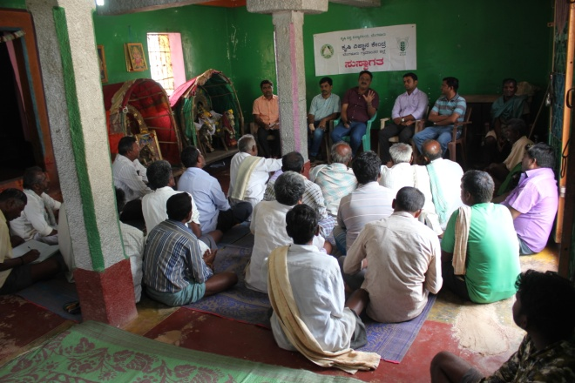 | 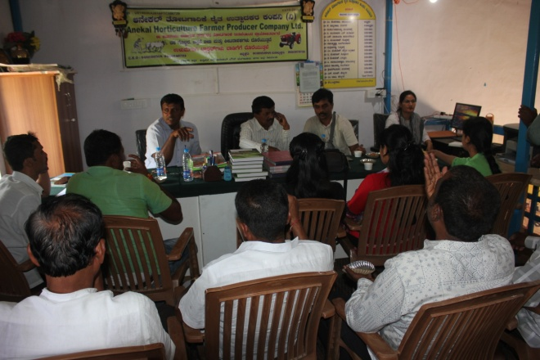
Village adoption - PRA | FPO, Anekal - PRA

Workshop on Banana Cultivation

ICAR- Krishi Vigyan Kendra, Bengaluru Rural District, Lions Charities trust ® and Pesticides dealers association, Doddaballapura, jointly organized workshop on banana cultivation at Hosahalli village, Doddaballapura Taluk. Dr. A. P. Mallikarjuna Gowda, Senior Scientist and Head inaugurated the programme and discussed about the importance of tissue culture banana and cultural practices in banana cultivation. Dr. N. Nagaraj, Professor, Dept. of Plant Pathology, UAS, GKVK, Bengaluru briefed about the important diseases of banana and their management. Dr. Manjunath, B., Scientist (Plant Protection) discussed about pest management in banana. Dr. P. Veeranagappa highlighted about the nutrient management. Miss Vidya, SRF has explained about harvesting and post harvesting technologies in banana. About 65 farmers were participated in the workshop.
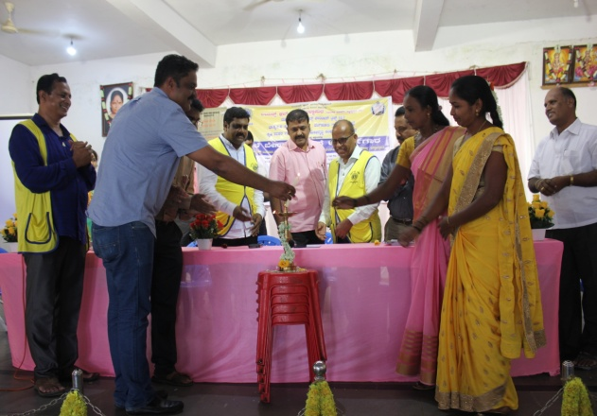 | 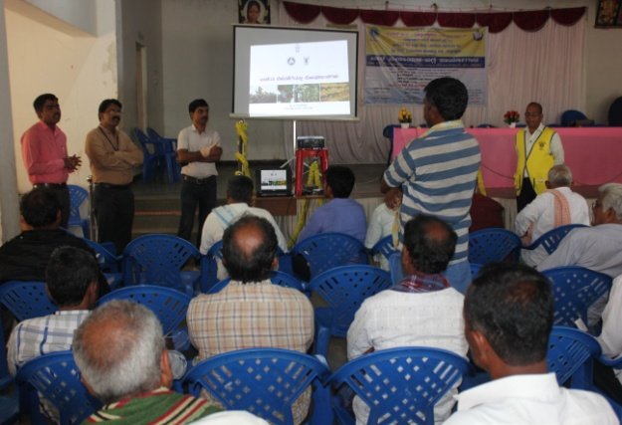
Banana workshop

Krishi Abhiyana Programmes
Karnataka State Department of Agriculture with various line departments has organized Krishi Abhiyana programmes at Bengaluru Rural District. KVK Scientists participated in different Krishi Abhiyana programmes organized in the district viz. Rajaghatta, Tubagere, Madhure, Doddabelavangala, Sasalu, Kundana, Channaraya patna and Vijayapura in Doddaballapur and Devanahalli Taluks and discussed about management of fall army worm in maize through Integrated approach and stressed upon the involvement of farming community in eradication of pest menace. Scientists also provided information about varieties, soil and water conservation, pest and disease management, nutrient management, activities of KVK and services of KVK available at KVK. MLAs of respective taluks were participated in the programme. Around 1650 farmers/farm women were benefitted from these programmes.
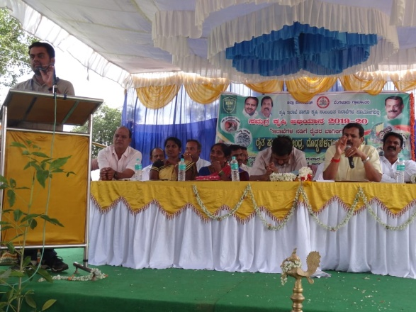 | 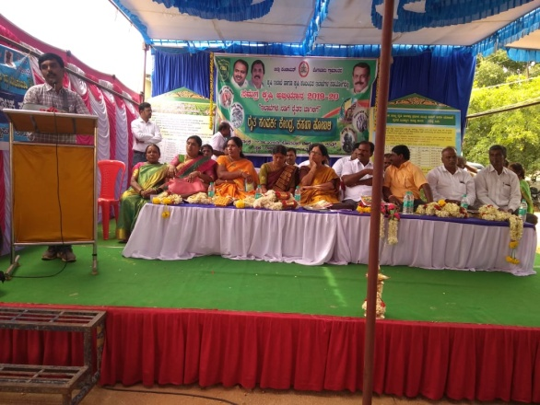
Krishi Abhiyana at Doddabelavangala | Krishi Abhiyana at Rajaghatta

Bioenergy Research, Information and Demonstration Centre activities
- Seeds procured - 1935.2 kgs
- Seeds crushed - 1920 kgs
- Cake produced - 1615 kgs
- pongamia oil obtained - 143 liters

Services available at KVK
- Analysis of soil and water samples and advisory services
- Analysis of infected plant samples and advisory services about IPM practices
- Production and sale of quality planting material and advisory services
- Production and sale of Vegetable Special
- Millets Processing Centre and KVK Marketing Complex
- Production and Sale of Pongamia oil, Pongamia cake and biofuel

Services and Sale of Technological Inputs
- Analysis of 71 Soil and 37 Water samples of farmers and advisory services
- Sale of 154 kg Vegetable Special for foliar spray in vegetables
- Sale of 210 quality horticultural planting materials
Plant Health Clinic
- Examination of infested plant samples and advisory services to the farmers
--------------------------------------------------------------------------------------------------------------
Chief Editor  Dr. A. P. Mallikarjuna Gowda  Senior Scientist & Head  Editor and Associate Editors  Dr. B. Manjunath  Scientist (Plant Protection) | Dr. J. Venkate Gowda.,  Scientist (Agronomy)  Dr. P. Veeranagapa.,  Scientist (Soil Science)  Dr. Y. D. Chithra.,  Scientist (Agril. Extension) |  | Sri N. Jagadish  Farm Manager  Smt. B. V. Manjula  Programme Assistant (Lab)
Contact For Further Information:  Senior Scientist & Head  ICAR- Krishi Vigyan Kendra  Hadonahalli, Doddaballapura Taluk,  Bengaluru Rural District, Karnataka – 561205  Phone: 94498 66928  Email: kvkbrd@gmail.com  Website: www.kvkbrd.org |  | To  ---------------------------------------------------------  ---------------------------------------------------------  ---------------------------------------------------------

