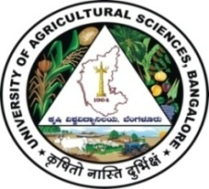 | University of Agricultural Sciences, Bangalore  ICAR-Krishi Vigyan Kendra, Bengaluru Rural District  Krishi Mantana  Vol. 7 Quarterly Newsletter (Jan - Mar, 2019) No. 1 | 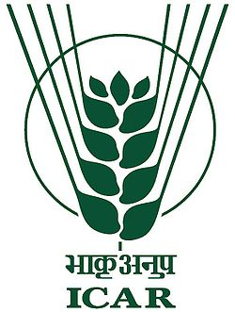

Rabi and Pre summer campaign

Rabi and Pre Summer campaign was organized by our KVK on 25th January 2019. Dr. A.P.Mallikarjuna Gowda, Senior Scientist and Head, Dr. T.Jayaram, Deputy Director, Department of Animal Husbandry, Bengaluru Rural District, Dr. B.S.Lalitha, Associate Professor , Department of Agronomy, UAS, GKVK, Bengaluru, Dr. Ananda Manegar, G., Assistant Professor (Animal Science), ATIC, UAS, GKVK, Bengaluru and Dr. Manjunath, B., Scientist (Plant Protection) graced the programmme. On this occasion Dr. A.P.Mallikarjuna Gowda urged the farmers to take up short duration high remunerative crops and stressed about integrated farming system approach to increase the farm income. Dr. B.S. Lalitha highlighted about improved cultivation practices of green fodder. Dr. Ananda Manegar, G. discussed about management of dairy animals in drought situations. Dr. Manjunath, B., discussed about management of pests and diseases of field and horticultural crops through integrated approach. 300 Farmers and farm women from different villages of Bengaluru Rural District participated in the progamme.

Training Programme for extension functionaries of Department of Horticulture, GoK

Organized training programme for extension functionaries of Department of Horticulture, GoK on Management of Major pests and diseases of Horticultural Crops under protected cultivation on 9th January, 2019 at our campus. Dr. A.P.Mallikarjuna Gowda, Senior Scientist and Head, Dr. Rudresh, Deputy Director, Department of Horticulture, Bengaluru Rural District and Dr. Manjunath, B., Scientist (Plant Protection) participated in the programme. Dr. A.P.Mallikarjuna Gowda explained about cultivation practices of different horticultural crops, importance of fertigation under protected cultivation. Dr. Manjunath, B., Scientist (Plant Protection) discussed about management of pests and diseases through integrated approach under protected cultivation. 38 officials from different taluks of Bengaluru Rural District participated in the programme.

Training Programme for extension functionaries of Department of Animal Husbandry, GoK

Training programme for extension functionaries of Department of Animal Husbandry, GoK on management of dairy animals and cultivation of green fodder was organized on 25th January, 2019. Dr. A.P.Mallikarjuna Gowda, Senior Scientist and Head, Mr. Kari Gowda, District Commissioner, Bengaluru Rural District, Dr. T. Jayaram, Deputy Director, Department of Animal Husbandry, Bengaluru Rural District, Dr. B.S.Lalitha, Associate Professor , Department of Agronomy, UAS, GKVK, Bengaluru, Dr. Ananda Manegar, G., Assistant Professor (Animal Science), ATIC, UAS, GKVK, Bengaluru and Dr. Manjunath, B., Scientist (Plant Protection) graced the programmme. Mr. Karigowda stressed to adopt Hydroponics technology in Farmers Field. Dr. B.S. Lalitha highlighted about improved cultivation practices of green fodder and silage. Dr. Ananda Manegar, G. discussed about management of dairy animals in drought situations.

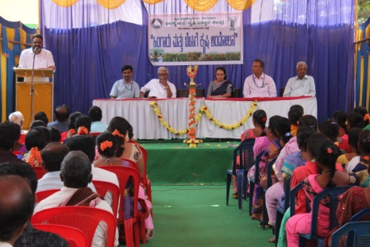 | 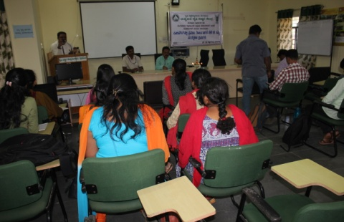 | 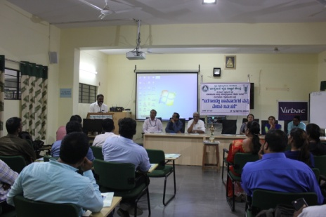
Rabi and Pre Summer campaign | Training on cultivation practices under protected cultivation | Training on management of dairy animals

Tenth Scientific Advisory Committee

- The Tenth Scientific Advisory Committee (SAC) meeting of ICAR-KVK, Bengaluru Rural District was held on 27.02.2019 under the Chairmanship of Vice-Chancellor, UAS, Bengaluru.
- The Senior Scientist and Head, presented the Action Taken Report on the recommendations of Ninth Scientific Advisory Committee meeting and obtained the approval. The Scientists presented the results of On Farm Testing, Front Line Demonstrations, Training Programmes, Farmers Field School, other extension activities, Adopted village programmes, Bio fuel project and ARYA project for the year 2017-18. Finally, the Senior Scientist and Head briefed the action plan for the year 2018-19.
- Leaflets on ‘Improved cultivation practices in millets, Improved production technologies in fodder crops, Pest and disease management in pole beans, Management of diamond back moth in cabbage, Nutrients for banana, Integrated nutrient management in tomato, Role of KVK in Farmers producer organizations and CDs on Success of Progressive farmers Smt. Channamma and Sri Lakshmi Narayana Gowda’ were released by the dignitaries.
- The demonstration units viz., NADEF method of composting, VAT method of composting, Azolla unit, Yelaga sheep unit, Swarnadhara poultry bird unit and Kadaknath bird units and Atomic Absorption Spectrophotometer were inaugurated by Hon’ble Vice Chancellor.

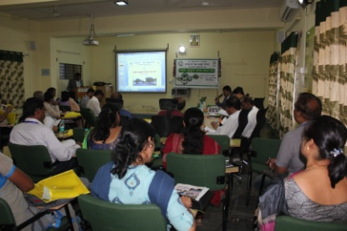 | 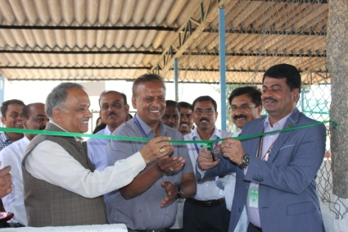 | 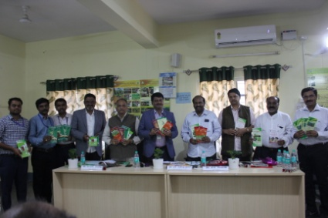
Discussion in SAC meeting | Inaguration of poultry unit by VC | Release of folders

Kissan mela

- ICAR-Krishi Vigyan Kendra, Bengaluru Rural District and ATMA, Department of Agriculture, Bengaluru District jointly organized Two days Kissan mela on 8th and 9th March 2019 at Krishi Vigyan Kendra, Hadonahalli.
- Dr. M. Veerappa moyili, Member of Parliament, Chikkaballapur Constituency appreciated the different programmes of UAS, Bengaluru and KVK, Bengaluru Rural District and he emphasized the farmers to utilize the government schemes effectively through commodity based associations.
- In the farmer Scientist interactive session, Plant protection measures in field and horticulture crops and Importance of soil and water were discussed. 375 farmers/farm women were participated in the programme.
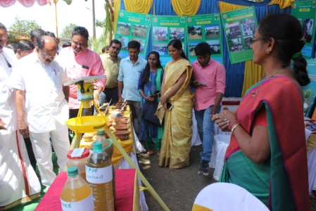 | 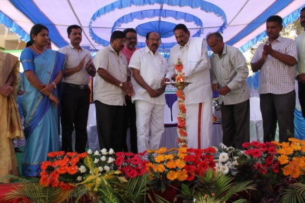 | 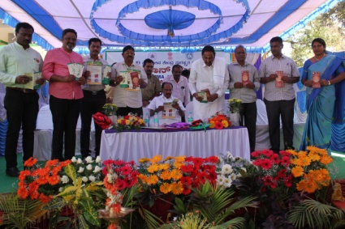
MP visited Exhibition stalls | Inaguration of Kisan mela | Release of folders

Training Programmes under ARYA project

- Organized six days vocational training programme on processing and value addition of Jack fruit from 18th to 23rd February 2019 for 35 members of Mahavruksha Jack growers Association under ARYA project. Dr. A. P. Mallikarjuna Gowda, Senior Scientist and Head, Dr. Kalpana, Professor, Department of Post harvest technology, GKVK, UAS (B), Scientists of KVK and ARYA project staff were participated in the programme.

- Six days vocational training programme on Processing and value addition of minor millets from 11th to 16th February 2019 for 35 members of Annapoorneshwari millets producers and processors Association under ARYA project.

- Organized six days training programme on “Improved agronomic practices for coconut crop and mechanization” from 18th to 23rd March 2019 for 20 Rural youths.

- “Bee keeping” training programme was organized from 11th to 16th March 2019 for 10 Rural youths.

- “Vermi composting” and “Nursery techniques” were organized from 25th to 30th March 2019. 57 Rural youths were benefited in the training programmes. The required implements and equipments were provided to all trainees.

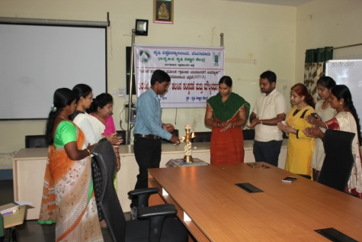 | 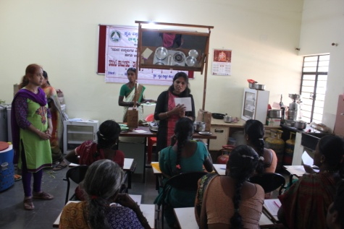 | 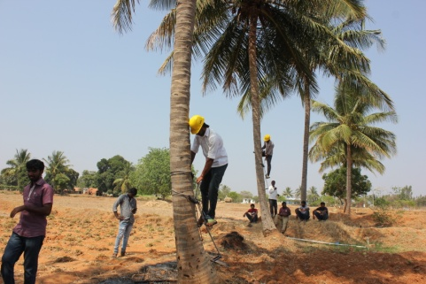
Training on Jack value addition | Millets value addition | Coconut climbing
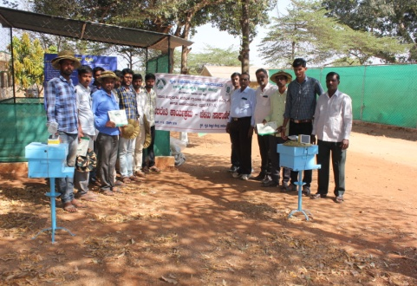 | 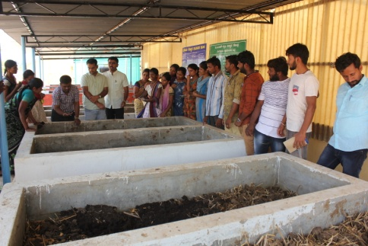 | 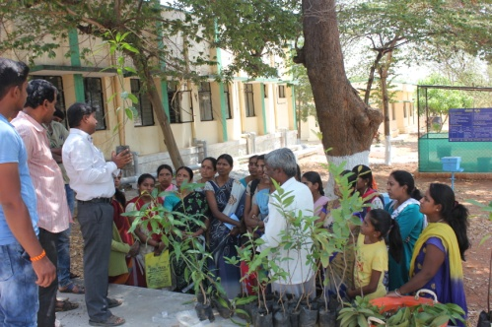
Bee keeping | Vermi composting | Nursery techniques

Bioenergy Research, Information and Demonstration Centre activities
- Awareness programme on Biofuel – Future fuel
- Awareness programme Bio fuel species and their importance
- Training programme on production and use of Bio fuel
- Training programme on use of bio fertilizers
- Training programme on use of biofuel
Services available at KVK
- Analysis of soil and water samples and advisory services
- Analysis of infected plant samples and advisory services about IPM practices
- Production and sale of quality planting material and advisory services
- Production and sale of Vegetable Special
- Millets Processing Centre and KVK Marketing Complex
- Production and Sale of Pongamia oil, Pongamia cake and biofuel
Services and Sale of Technological Inputs
- Analysis of 370 soil and 166 water samples of farmers and advisory services
- Sale of 172 kg Vegetable Special as foliar spray in vegetables
- Sale of 58 quality horticultural planting materials
Plant Health Clinic
- Examination of 15 infested plant samples and advisory services to the farmers
--------------------------------------------------------------------------------------------------------------
Chief Editor  Dr. A. P. Mallikarjuna Gowda  Senior Scientist & Head  Editor and Associate Editors  Dr. B. Manjunath  Scientist (Plant Protection) | Dr. J. Venkate Gowda., Scientist (Agronomy)  Dr. P. Veeranagapa., Scientist (Soil Science)  Dr. Y. D. Chithra., Scientist (Agril. Extension) |  | Sri N. Jagadish  Farm Manager  Smt. B. V. Manjula  Programme Assistant (Lab)
Contact For Further Information:  Senior Scientist & Head, ICAR- Krishi Vigyan Kendra, Hadonahalli, Doddaballapura Taluk, Bengaluru Rural District, Karnataka – 561205 Phone: 94498 66928  Email: kvkbrd@gmail.com ,  Website: www.kvkbrd.org |  | To  ---------------------------------------------------------  -----------------------------------------------------------

