Enhancing resource use efficiency in castor based cropping systems

- Agro-techniques were standardized for rabi castor. Among different sowing schedules, planting during 1st Week of Oct registered the highest mean seed yield (2614 kg/ha), net returns (Rs. 69332) and B: C ratio (3.31) with delay in planting from Oct 1st to Nov. 15th, seed yield of castor was declined by about 30%. Among the castor hybrids, significantly highest seed yield was recorded in DCH-519 (2985 kg/ha) which was at par with GCH-7 (2884kg/ha) followed by YRCH-1 (2184 kg/ha).Highest mean seed yield was obtained when accumulation of growing degree days, Helio thermal units, photo thermal units and Heat use efficiency was highest .

- Significantly higher rabi castor seed yield (3302 kg/ha) and oil yield (1599 kg/ha) were registered when irrigations were scheduled by drip at 0.8 Epan along with supply of full amount of N& K through fertigation. Drip irrigation resulted in saving of 27% water with high water-use efficiency (3.53 to 4.85 kg/ha-mm) (Plate 1 and 1a)

- Moisture and nutrient dynamics on sorghum – castor cropping system in Alfisol under rainfed condition in fixed plot revealed that under normal rainfall distribution, application of FYM along with 100% or 50% NPK recorded highest seed yield. Under drought situation, application of 25%N through FYM along with 75% NPK as inorganic fertilizer resulted in significantly highest mean seed yield of sorghum (3117kg/ha; SYI 0.72) and castor (910 kg/ha; SYI 0.05). The INM practice also resulted in higher organic C (0.5%) and available N (210 kg/ha). Moisture content was higher in organic treatments. Substituting 25% N requirement through FYM can mitigate the effects of drought effectively with sustainable soil fertility (plate 2
Plate 1: An overview of drip-fertigation experiment customized for rabi castor (DCH-519)
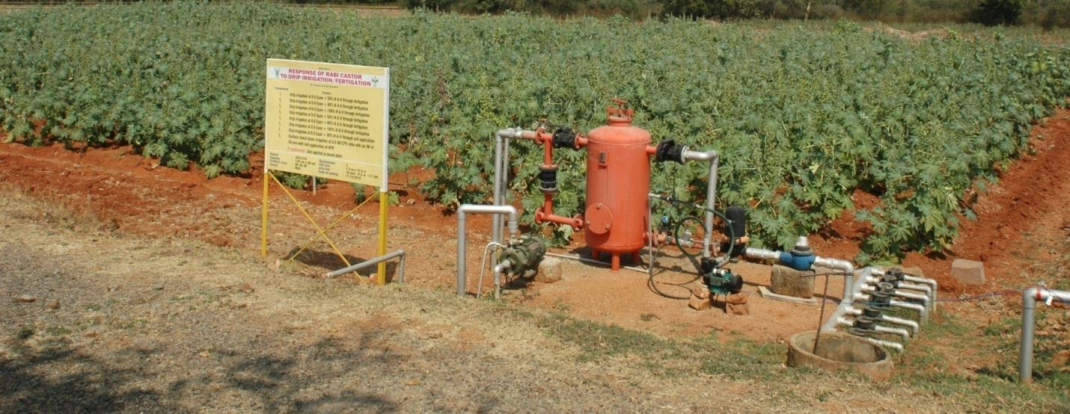

Plate 1( a) Performance of rabi castor at drip-scheduling at 0.8 Epan_ 80% N and K through fertigation

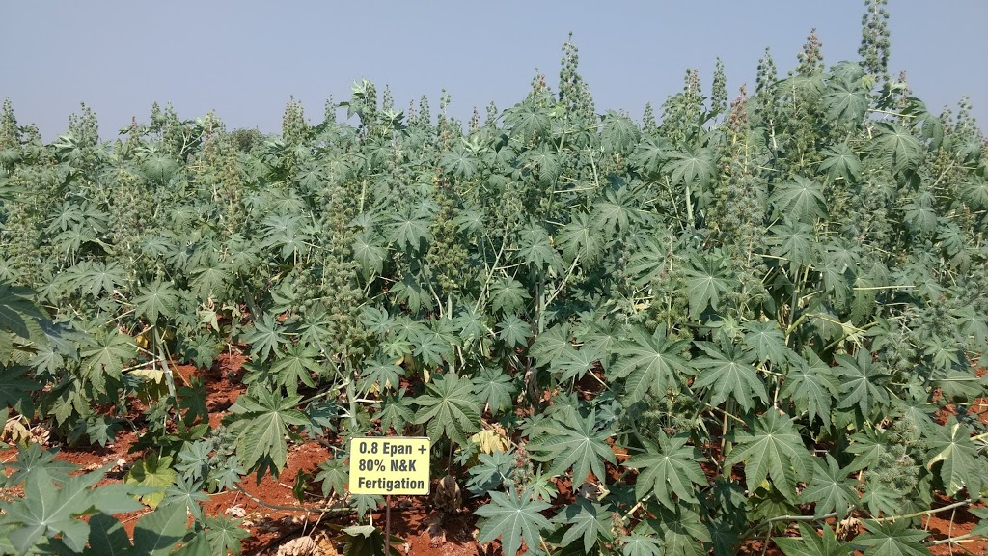

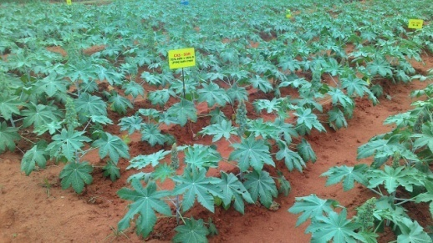

Plate 2 & 2a: Moisture and nutrient utilization dynamics in castor – sorghum cropping system due to integrated nutrient management under rainfed conditions in Alfisols

