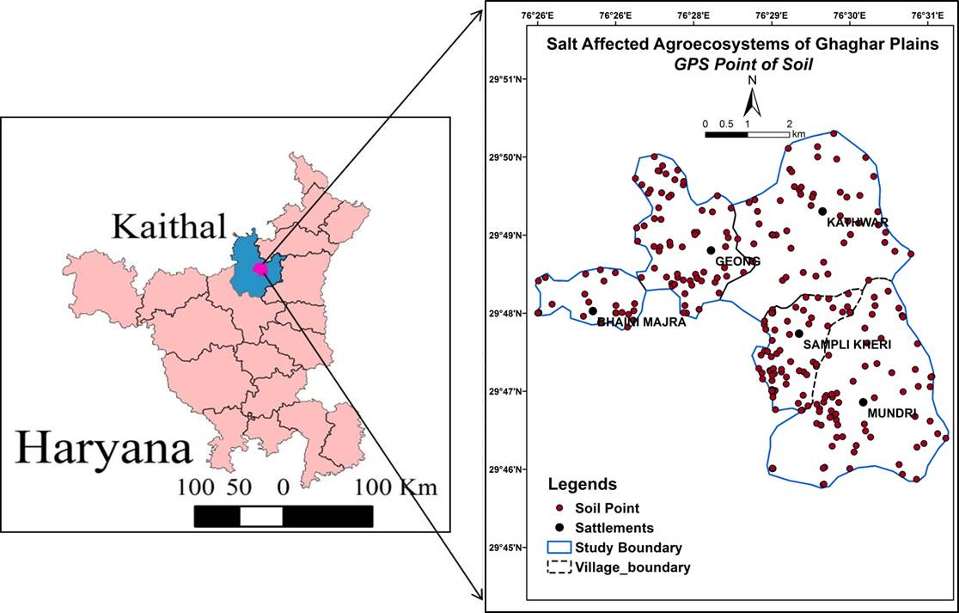

Fig. 1. Location map of study area and GPS marked soil sampling points
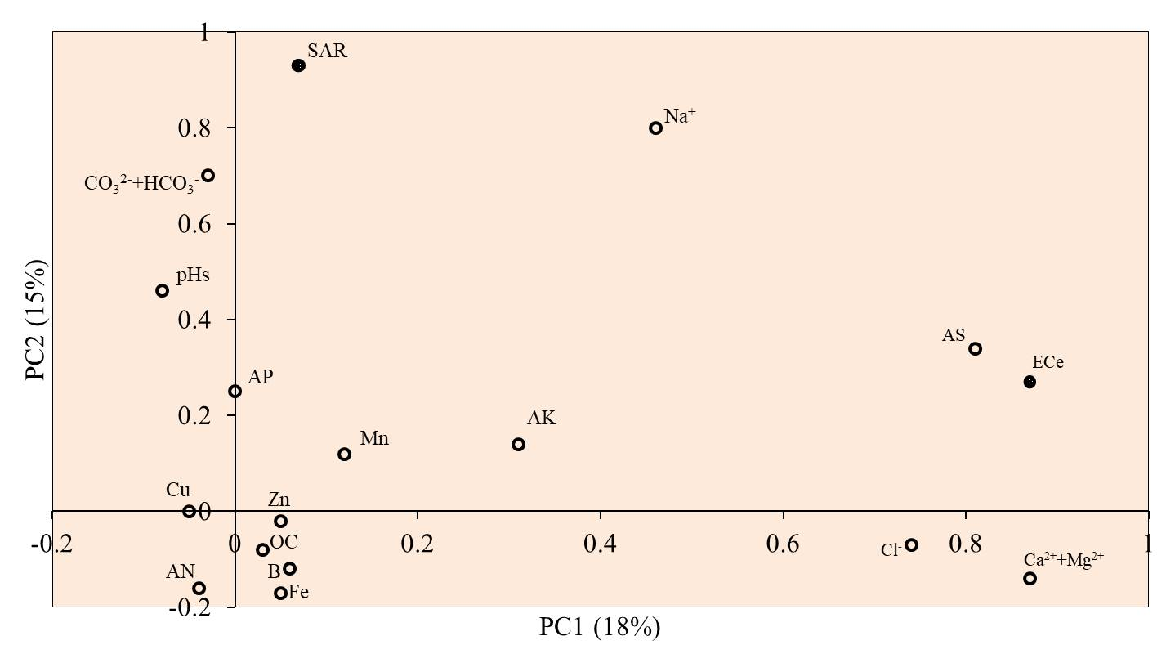
Fig. 2. Loading lot of soil sodicity and fertility parameters
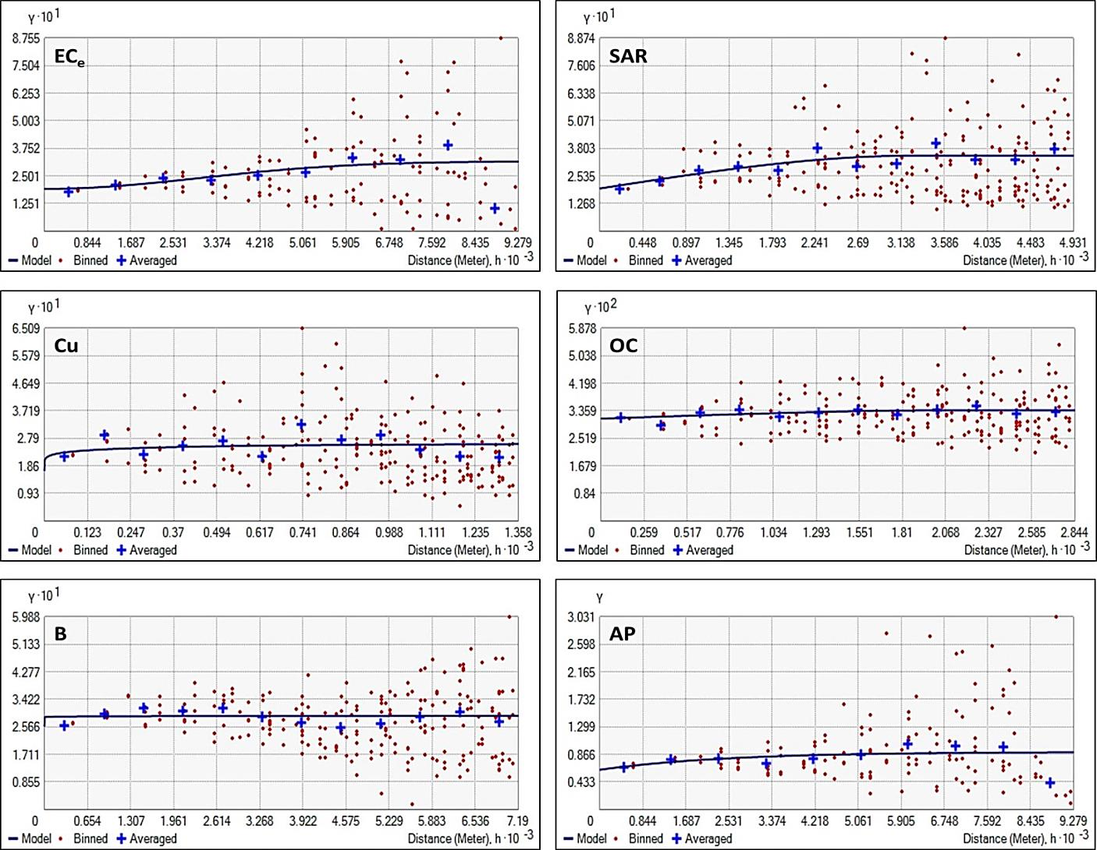
Fig. 3. Calculated semivariograms of principal soil parameters in response to selected best fit model

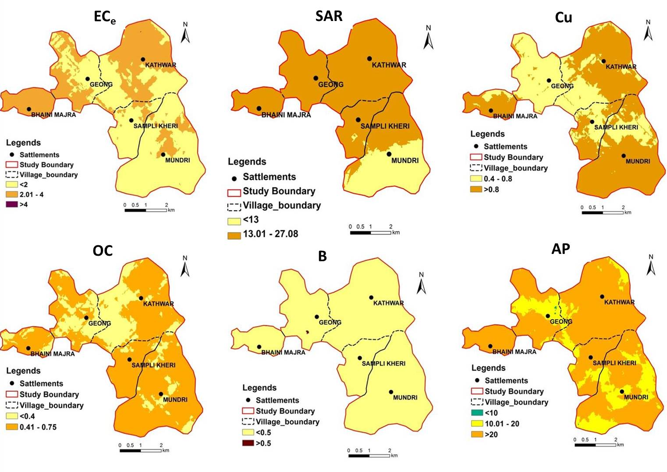
Fig. 4. Spatial variability of principal soil parameters to develop SQI and delineate SMZs

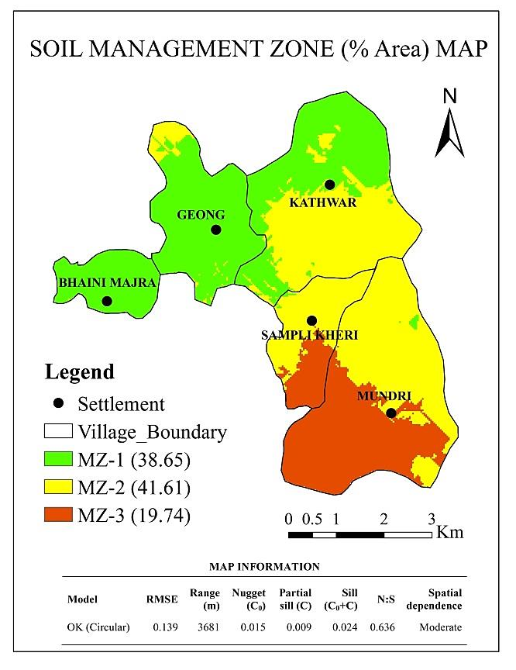
Fig. 5. Spatial variability and dependency of soil management zones parameters

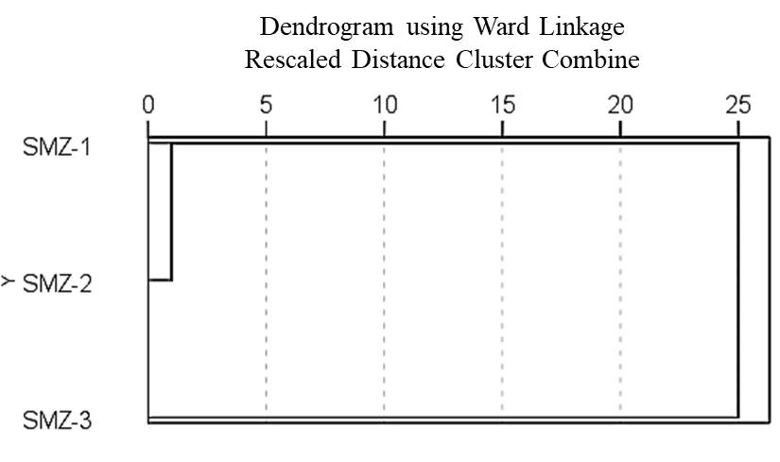
Fig. 6. Dendrogram obtained by hierarchical clustering analysis of different SMZs

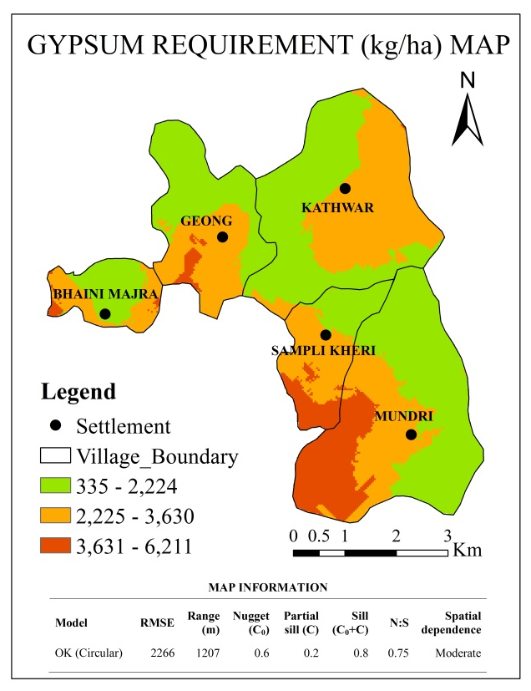
Fig. 7. Spatial variability for gypsum requirement

